ASSIGNMENT 7
SELECT

You must execute the statements in the order in which the questions are being asked.

Suggestions:
- Do not create a spool file. This lab will probably take several days. Since you cannot guarantee that the work that you did on my home computer or the lab computers on campus will be there the next time you open up the SQLPlus session, I would make the following suggestion: Store all your SQL statements in a text file. Then you can just copy and paste your SQL statements into the SQLPlus session and get back to where you left off.

- I would also suggest that you drop all your tables in the beginning of the text file just in case the tables are still there so that you don’t get any error messages

All the tables that you create should be prefixed with the first five letters of your lastname such as sabze_patient

What to turn in:
- You will turn in this word document only. I do not want any other files
- Paste a printscreen of either the SQLPlus session or SQL Developer showing only the SQL command and the results from the database engine. Some of the SQL statements that you issue may cause an error and may actually be the expected result. Do not assume that just because you are not getting an error message, everything is okay.
- When typing in your SQL statements, make sure that the keywords are all in uppercase. The identifiers that you come up with such as table names, column names or constraint names should all be in lower case.
- Make sure that you prefix your table names with the first five letters of your last name.
- Make sure that you only provide a printscreen of the snippet that pertains to the question (NOTHING MORE).

Suggestion: you can use the snipping tool in windows 7 or you can download this open source program http://getgreenshot.org/ for printscreens. Provide only the printscreen that pertains to the question. I do not want to see your trial and errors or things that pertain to other questions.

SQLPlus or SQLDeveloper (Your choice)
Example | Display the contents of the dual table
 | 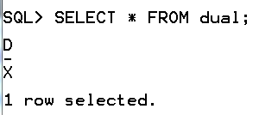 OR 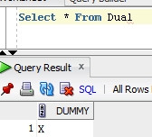
Next Example | Create a table called test
 | 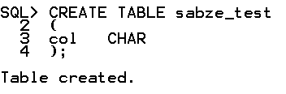 OR 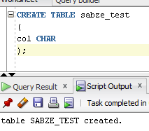

All the tables that you create must be prefixed with the first five letters of your last name such as sabze_student.

0 | Copy and paste the contents of student.txt into your SQLPlus or SQLDeveloper session. Rename the tables such that they are all prefixed with the first five letters of your lastname such as sabze_student. Make sure that the tables (student, class and student_class) are all renamed properly before you continue.
1 |  | Using a single SQL statement display fname, lname, dob, salary for all the students whose age is greater than 15. (Have to convert the dob to years)
 |  | 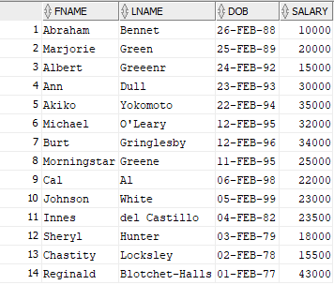
2 |  | Using a single SQL statement display the following from the student table.  ssn, lname and fname concatenated together with a comma and a space separating the two (e.g sabzevary, IRAJ). The last name should be all lower case. The first name should be all upper case. The heading on the column should be Full_Name (Use the concat function or the || symbols)
NOTE: Wasn’t sure how ssn, lname, and fname should be formatted, so two solutions are provided.

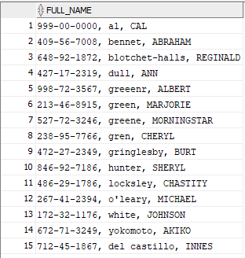

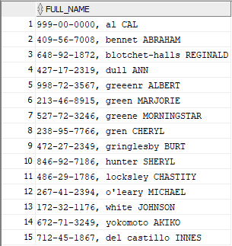

3 |  | Using a single SQL statement display fname, lname, dob, salary from the student table where the lname contains the letters ‘h’ or ‘a’ regardless of case (Use the like clause)
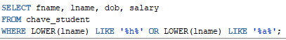

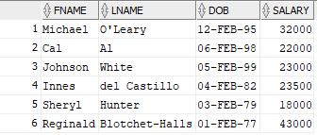
4 |  | Using a single SQL statement display fname, lname, dob, salary from the student table where age is between 15 and 25. (use the between clause) and fname starts with ‘abr’ regardless of case. If the dob is null, display ‘not born yet’ (USE NVL)
 |  | 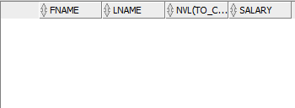
5 |  | Using a single SQL statement display fname, lname, dob, salary from the student table where the dob is not null. If the salary is <20000 display ‘poor’ otherwise display ‘rich’ (Use decode)
NOTE: First solution doesn’t handle 0 result of the SIGN function, Second solution does.

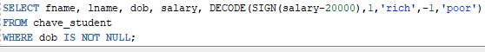

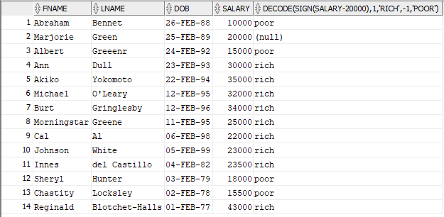

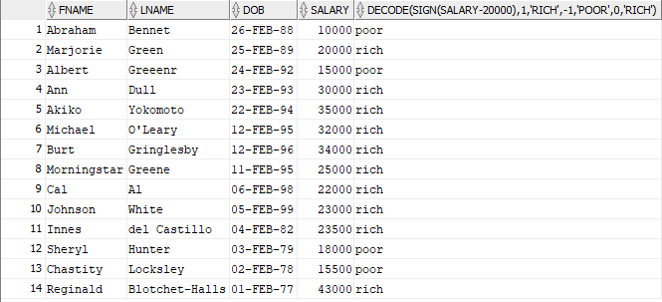
6 |  | Using a single SQL statement display the square root of dob plus 20 divided by 5 from the student table( CAUTION: The order of precedence is as the question is read. Use paranthesis) (Have to convert dob to years first)
 |  | 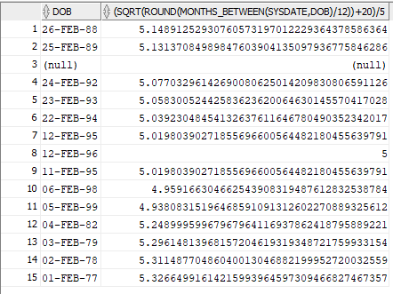
7 |  | Using a single SQL statement display fname, lname, dob, salary from the student table where the first name of the student can be anything except John, Jack or Bob. (Use the IN or NOT IN syntax)
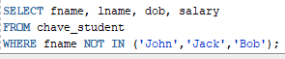

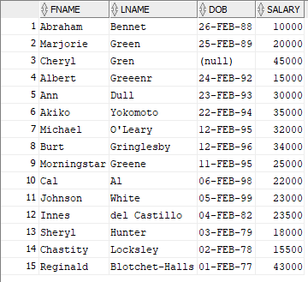

8 |  | Using a single SQL statement display fname, lname, dob, salary from the student table where the fname is only three characters long; the first character and second characters can be anything, but the third character must be ‘b’ (e.g. bob, cib, lib, hub, mob). Also the salary must be greater than 10000 and the phone number must start with ‘527’
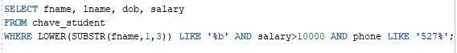

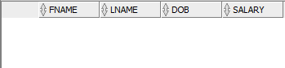
9 |  | Create a new table called student2 that contains the results from the following SQL statement: fname, lname, salary*2 from the student table where last name contains the letters ‘nn’ (e.g. Benny, Bonny, Sonny) and dob does not contain any data. (NOTE: Beware of salary*2 for the create table statement)
 |  | 